# CS 340 README for Grazioso Salvare’s Custom Dashboard

# About the Project

This project was undertaken to develop a functional, web-based dashboard for Grazioso Salvare, enabling them to review animals available at the Austin Animal Shelter that meet their specific business requirements.

This project consists of three layers:

* A MongoDB layer which contains the data needed for visualization
* A Python middle-ware layer that is used for control
* A Plotly-, Dash-, Leaflet-based visualization layer to produce the html

The Python middleware is using a custom class that facilitates Create-Read-Update-Delete (CRUD) actions in MongoDB via the Pymongo driver. The class will contain all the abstracted getter/setter methods needed for CRUD operations and MongoDB initiation.

# Component Selection Methodology

MongoDB was selected over SQL for its user-friendly nature and flexibility. Its dynamic schema minimizes errors during updates or creation operations, such as entering a decimal value for age when it was expected to be an integer. Additionally, MongoDB's JSON format integrates seamlessly with web environments, making it a more suitable choice.

MongoDB does not guarantee the same level of ACID properties as SQL, but this tool is not expected to have many transactions so this issue can be disregarded.

Python was selected due to its extensive set of tools for integrating the backend and frontend. For instance, the PyMongo driver facilitates interaction with MongoDB through the CRUD class and a middleware layer. Additionally, Python enables the creation of HTML/JavaScript-based dashboards and widgets using libraries such as Plotly-Dash and Dash Leaflet.

The Plotly-Dash and Dash Leaflet libraries serve as Python wrappers for JavaScript-based tools, enabling interaction through their respective APIs. These libraries allow for the creation of SVG elements like pie charts, tiled PNG maps, and the raw HTML and CSS necessary to render data tables and widgets.

#### CRUD Class

CRUD operations are essential when working with any database, but formatting queries and handling errors can be a time-consuming process. To simplify this, these operations have been abstracted into straightforward get and set methods, reducing the need to format each query or rewrite code for various error types.

The class contains the following methods:

* Constructor (password, username)
* createRecord(data)
* deleteRecord (query)
* getRecordId(data)
* getRecordCriteria(criteria = None)
* updateRecord (query, newValue)

And properties:

* records_updated
* records_matched
* records_deleted

For more information on the CRUD class refer to the specific readme.

# Installation/Pre-Conditions

To use this software the following tools must be installed:

* Python 3.6
* Pymongo 4.2: [link](https://pymongo.readthedocs.io/en/stable/)
* MongoDB 4.2: [link](https://www.mongodb.com/)
* Plotly Dash: [link](https://dash.plotly.com/)
* Dash Leaflet: [link](https://dash-leaflet.herokuapp.com/)
* Data available in a Mongo database collection, see example on importing a CSV
* User account with read/write permissions

## Product Walkthrough

Grazioso Salvare requested the dashboard to have a few key components:

* Branding with logo
* A link to their website
* A data table, with custom filters, containing the information about the animals at the Austin Animal Shelter
  + Custom filters provide targeted animals for specific business needs, including:
    - Water Rescue
    - Mountain or Wilderness Rescue
    - Disaster Rescue or Individual Tracking
* A pie chart showing the breakdown of available breeds
* A map with the location of a selected animal

**Mokongwu SNHU CS-340 Dashboard**

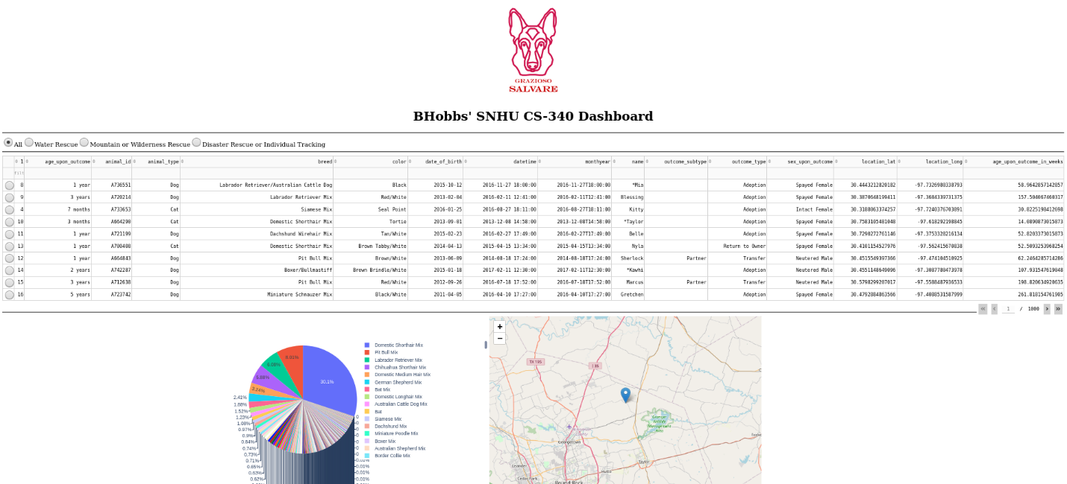

Client Logo also serving as a link to their homepage

Custom filters prebuilt for common searches

Data table that dynamically responds to user input

Dynamic pie chart showing available breeds

Map showing location of any selected animal

Toggle to control map

Inline filters and sorting available

The custom filters are set with the specifications provided by the client, see below.

Depending on the filter choose by a user the pie chart and data table will update, below is an example.



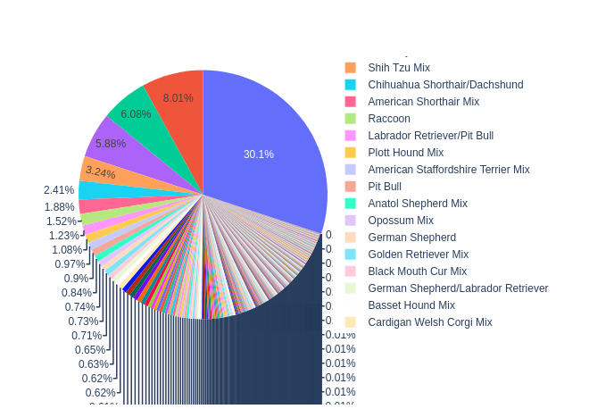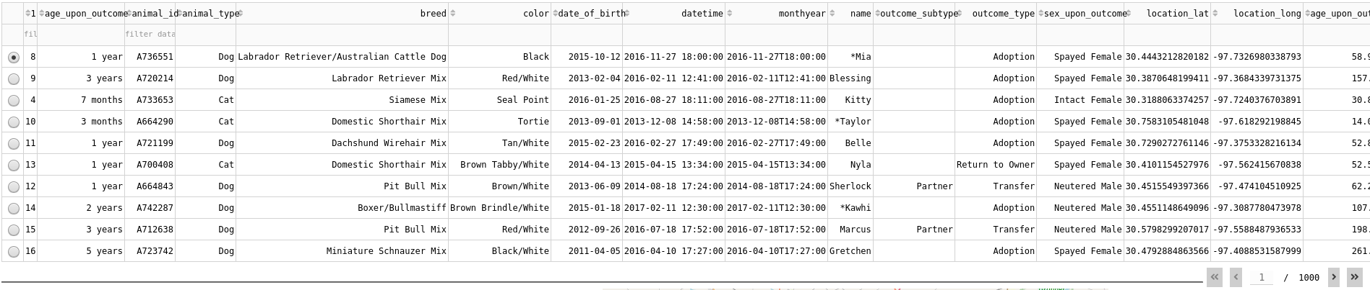



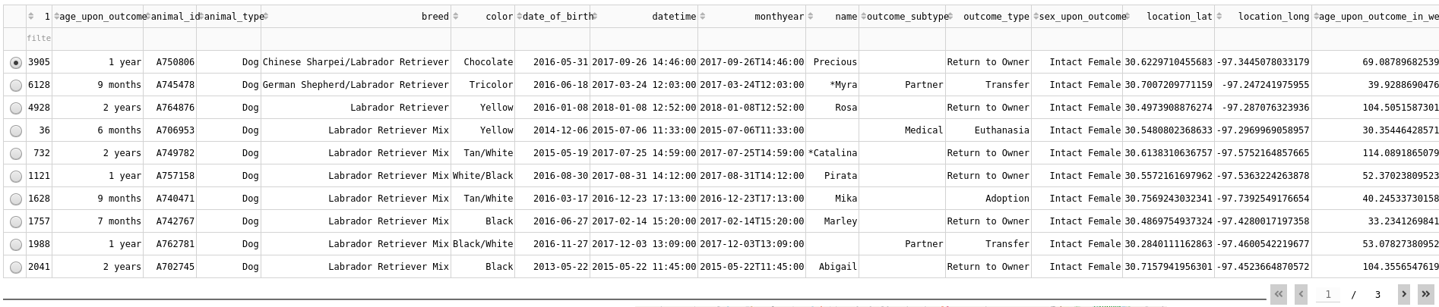



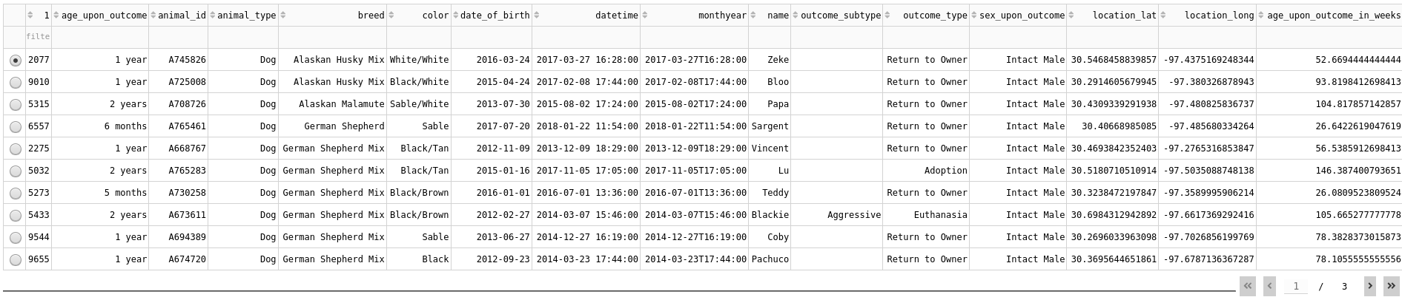



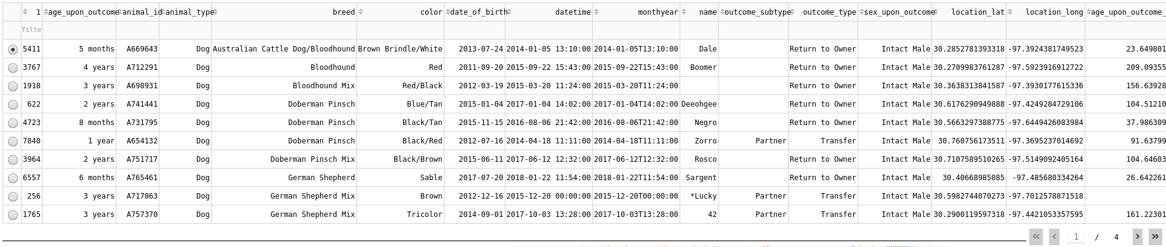

when an animal is selected its location is shown on the map, otherwise the Austin Animal Shelter is shown, below is an example.

when the map marker is clicked the name of the animal will show and the breed is shown on hover.

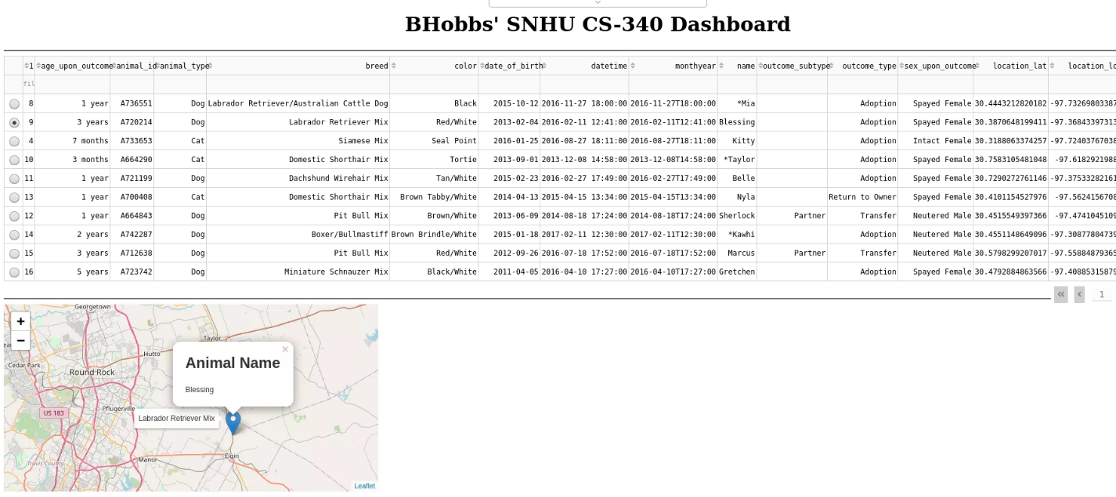

# Project Recreation

If this project was to be recreated because of server migration or failed back up the next steps would be followed.

1. Install the required components, see section *Installation/Pre-Conditions*
2. Use an admin account to load data into MongoDB, *mongoimport* is suggested  
   
3. Create the needed user roles (CRUD class does not need full admin rights just read/write) – two accounts (admin and a user role) are shown below  
   Text

   Description automatically generated  
     
   Text

   Description automatically generated
4. Add the CRUD class and the middleware-dashboard driver to the host server
5. Update the middleware-dashboard driver with username and password created in **Step 3**  
   Graphical user interface, text, application

   Description automatically generated
6. Add the Dash components and their callbacks (see Appendix) as needed
   * Data table code example  
     Graphical user interface, text, application

     Description automatically generated
   * Html div holding widgets example  
     Graphical user interface, text, application

     Description automatically generated
   * Radio buttons acting as filters example  
     A picture containing company name

     Description automatically generated
   * Html anchor for logo and link to homepage example  
     
7. Update any regular expressions used for filtering if they have changed, *Water Rescue* is shown  
   Text

   Description automatically generated
8. Start MongoDB
9. Start the Python middleware-dashboard driver

# Pit Falls and Struggles

For those attempting to recreate the project, the primary challenge was filtering the Austin Animal Shelter data. Grazioso Salvare had specific breed requirements for dogs, but the database contained inconsistencies in the data. For instance, while Grazioso Salvare was interested in the Chesapeake Bay Retriever breed, it was recorded as "Chesa Bay Retr" in the raw data. This required the use of pattern matching to generate an accurate list of animals. Regular expressions were used for this purpose. However, since PyMongo does not natively support regular expressions, they had to be formatted appropriately for compatibility with the PyMongo API.

## Contact

Malachi Okongwu, [malachi.okongwu@snhu.edu](mailto:malachi.okongwu@snhu.edu), created for SNHU CS-340 on December 15, 2024

# Appendix

# Dash callbacks

#############################################

# Interaction Between Components / Controller

#############################################

*@app.callback([Output('datatable-id','data'),*

*Output('datatable-id','columns')],*

*[Input('filter-type', 'value')])*

*def update_dashboard(filter_type):*

*#set up an if/else if/else block to respond to the radio buttons*

*if filter_type == 'All':*

*df = pd.DataFrame.from_records(shelter.getRecordCriteria({}))*

*elif filter_type == 'Water':*

*#data isn't that clean, use regex for pattern matching*

*#build the regex patterns for the different filters*

*labRegex = re.compile(\".*lab.*\", re.IGNORECASE)*

*chesaRegex = re.compile(\".*chesa.*\", re.IGNORECASE)*

*newRegex = re.compile(\".*newf.*\", re.IGNORECASE)*

*df = pd.DataFrame.from_records(shelter.getRecordCriteria({*

*'$or':[ #Regex isn't allowed in an $in helper so use $or*

*{\"breed\": {'$regex': newRegex}}, #pass the regex to the filter*

*{\"breed\": {'$regex': chesaRegex}},*

*{\"breed\": {'$regex': labRegex}},*

*],*

*\"sex_upon_outcome\": \"Intact Female\",*

*\"age_upon_outcome_in_weeks\": {\"$gte\":26.0, \"$lte\":156.0}*

*}))*

*elif filter_type == 'Mountain':*

*germanRegex = re.compile(\".*german.*\", re.IGNORECASE)*

*alaskanRegex = re.compile(\".*mala.*\", re.IGNORECASE)*

*oldRegex = re.compile(\".*old engilish.*\", re.IGNORECASE)*

*huskyRegex = re.compile(\".*husk.*\", re.IGNORECASE)*

*rottRegex = re.compile(\".*rott.*\", re.IGNORECASE)*

*df = pd.DataFrame.from_records(shelter.getRecordCriteria({*

*'$or':[*

*{\"breed\": {'$regex': germanRegex}},*

*{\"breed\": {'$regex': alaskanRegex}},*

*{\"breed\": {'$regex': oldRegex}},*

*{\"breed\": {'$regex': huskyRegex}},*

*{\"breed\": {'$regex': rottRegex}},*

*],*

*\"sex_upon_outcome\": \"Intact Male\",*

*\"age_upon_outcome_in_weeks\": {\"$gte\":26.0, \"$lte\":156.0}*

*}))*

*elif filter_type == 'Disaster':*

*germanRegex = re.compile(\".*german.*\", re.IGNORECASE)*

*goldenRegex = re.compile(\".*golden.*\", re.IGNORECASE)*

*bloodRegex = re.compile(\".*blood.*\", re.IGNORECASE)*

*doberRegex = re.compile(\".*dober.*\", re.IGNORECASE)*

*rottRegex = re.compile(\".*rott.*\", re.IGNORECASE)*

*df = pd.DataFrame.from_records(shelter.getRecordCriteria({*

*'$or':[*

*{\"breed\": {'$regex': germanRegex}},*

*{\"breed\": {'$regex': goldenRegex}},*

*{\"breed\": {'$regex': bloodRegex}},*

*{\"breed\": {'$regex': doberRegex}},*

*{\"breed\": {'$regex': rottRegex}},*

*],*

*\"sex_upon_outcome\": \"Intact Male\",*

*\"age_upon_outcome_in_weeks\": {\"$gte\":20.0, \"$lte\":300.0}*

*}))*

*else:*

*raise Exception(\"Unknown filter\")*

*columns=[{\"name\": i, \"id\": i, \"deletable\": False, \"selectable\": True} for i in df.columns]*

*data=df.to_dict('records')*

*return (data,columns)*

*#change the color of a selected cell*

*@app.callback(*

*Output('datatable-id', 'style_data_conditional'),*

*[Input('datatable-id', 'selected_columns')]*

*)*

*def update_styles(selected_columns):*

*return [{*

*'if': { 'column_id': i },*

*'background_color': '#D2F3FF'*

*} for i in selected_columns]*

*#call back for pie chart*

*#set to plot all of the data across all of the pages instead of the viewable data*

*#change to derived_viewport_data if other behavior is wanted*

*@app.callback(*

*Output('graph-id', \"children\"),*

*[Input('datatable-id', \"derived_virtual_data\")])*

*def update_graphs(viewData):*

*dffPie = pd.DataFrame.from_dict(viewData)*

*return [*

*dcc.Graph(*

*figure = px.pie(dffPie, names='breed',)*

*)*

*]*

*#call back for slecting a row and then plotting the geomarker*

*@app.callback(*

*Output('map-id', \"children\"),*

*[Input('datatable-id', \"derived_virtual_selected_rows\")])*

*def update_map(virtualRows):*

*#austin Texas is [30.75, -97.48]*

*#create the views*

*if not virtualRows: #build a default view if there are no selected lines*

*markerArray = (30.75,-97.48) #default marker at Austin Animal Shelter*

*toolTip = "Austin Animal Center"*

*popUpHeading = "Austin Animal Center"*

*popUpParagraph = "Shelter Home Location"*

*else: #build the contextual views based on the selection*

*dff = pd.DataFrame(df.iloc[virtualRows]) #convert the datatable to a dataframe*

*coordLat = float(dff['location_lat'].to_string().split()[1]) #strip out the lat*

*coordLong = float(dff['location_long'].to_string().split()[1]) #strip out the long*

*markerArray = (coordLat, coordLong) #build the array based on selection*

*toolTip = dff['breed']*

*popUpHeading = "Animal Name"*

*popUpParagraph = dff['name']*

*#return the map with a child marker*

*#marker is set to the values found in markerArray*

*#map centers/moves to view the new marker instead of holding a fixed center*

*return [dl.Map(style={'width': '700px', 'height': '450px'}, center=markerArray,*

*zoom=10, children=[dl.TileLayer(id=\"base-layer-id\"),*

*dl.Marker(position=markerArray, children=[*

*dl.Tooltip(toolTip),*

*dl.Popup([*

*html.H1(popUpHeading),*

*html.P(popUpParagraph)*

*])*

*])*

*])*

*]*